### AI-Statistical Machine Learning Approaches to

### Liver Disease Prediction

**Team ID: PNT2022TMID48272**

**Faculty Mentor Team Leader:** G.lydia

D.**Pradhiba Team Member:** R.priya

**TeamMember:**U.lavanyasri

**TeamMember:**G.nagalakshmi

### Checking for null values and Handling Null Values:

### This method commonly used to handle the null values. Here, we either delete a particular row if it has a null value for a particular feature and a particular column if it has more than 70-75% of missing values. This method is advised only when there are enough samples in the data set. Missing values can be handled by deleting the rows or columns having null values. If columns have more than half of the rows as null then the entire column can be dropped. The rows which are having one or more columns values as null can also be dropped

* We will be using isnull().any() method to see which column has missing values.
* This isnull().any() method return two values, False and True.
* False return that Column has No Null Values.
* True return that Column has Null values.

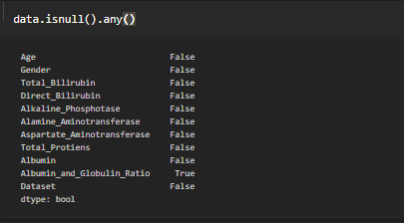

Let us check how many numbers of null records present in the Closing Value column using sum() function.

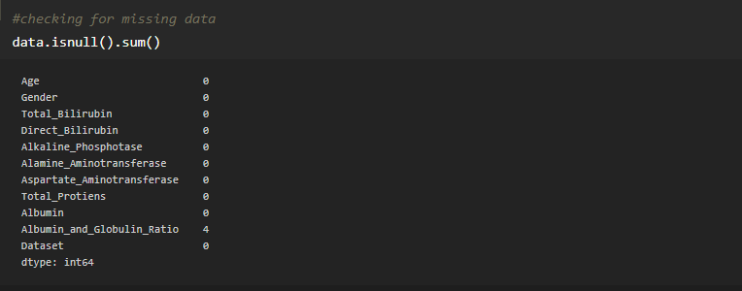

We can notice that, there are 4 null values are there in the column Albumin_and_Globulin_Ratio. Now will handle or fill that null values with the help of fillna() method.

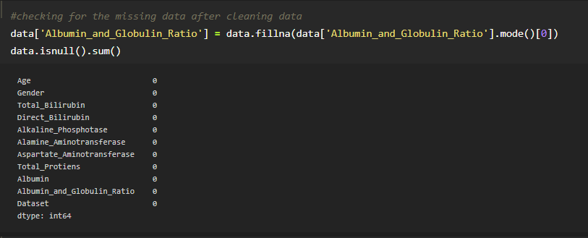

In real world data, there are some instances where a particular element is absent because of various reasons, such as, corrupt data, failure to load the information, or incomplete extraction. [Handling](https://analyticsindiamag.com/get-started-preparing-data-machine-learning/) the missing values is one of the greatest challenges faced by analysts, because making the right decision on how to handle it generates robust data models. Let us look at different ways of imputing the missing values.